

**Experiment No 4:** Implement of Linear Queue ADT using Array

**Aim:** To implement a Queue using arrays.

**Objective:**

● Understand the Queue data structure and its basic operations.

● Understand the method of defining Queue ADT and its basic operations.

● Learn how to create objects from an ADT and member functions are invoked.

**Theory:**

A Queue is an ordered collection of items from which items may be deleted at one end (called the front of the queue) and into which items may be inserted at the other end (the rear of the queue). Queues remember things in first-in-first-out (FIFO) order. The basic operations in a queue are: Enqueue-Adds an item to the end of the queue. Dequeue - Removes an item from the front

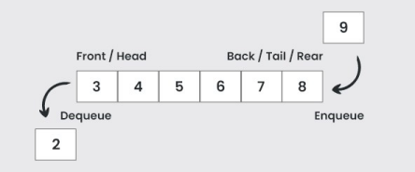

A queue is implemented using a one dimensional array. FRONT is an integer value, which contains the array index of the front element of the array. REAR is an integer value, which contains the array index of the rear element of the array. When an element is deleted from the queue, the value of front is increased by one. When an element is inserted into the queue, the value of rear is increased by one.

Infix

Postfix

**Algorithm:**

ENQUEUE(item)

1. If (queue is full)

Print ”overflow”

2. if (first node insertion) Front++

3. rear++

Queue[rear]=value

DEQUEUE()

1. If (queue is empty)

printf “underflow”

2. if (front=rear)

Front=1 and rear=-1

3. t=queue[front]

4. front++

5. return t

ISEMPTY()

1. If(front=-1) then

return 1

2. return 0

ISFULL()

1. If (rear=max)then

return 1

2. return 0

Code :

#include<stdio.h>

#include<stdlib.h>

#include<conio.h>

#define MAX 50

void insert();

void dequeue();

void display();

int queue_array[MAX];

int rear=-1;

int front=-1;

void main()

{

int choice;

clrscr();

while (1)

{

printf("\n1.Insert element to queue\n"); printf("\n2.Delete element from queue\n"); printf("\n3.Display all elements of queue\n"); printf("\n4.Quit\n");

printf("\n Enter your choice:");

scanf("\n%d",&choice);

switch (choice)

{

case 1:

insert();

break;

case 2:

dequeue();

break;

case 3:

display();

break;

case 4:

exit(1);

default:

printf("\n Wrong choice \n");

}

}

}

void insert()

{

int item;

if (rear==MAX-1)

printf("\n Queue overflow \n");

else

{

if(front==-1)front=0;

printf("\n Insert the element in the queue:"); scanf("\n%d",&item);

rear=rear+1;

queue_array[rear]=item;

}

}

void dequeue()

{

if(front==-1||front>rear)

{

printf("\n Queue underflow\n");

return;

}

else

{

printf("\nElement deleted from queue is: %d\n",queue_array[front]); front=front+1;

}

}

void display()

{

int i;

if(front==-1)

printf("\nQueue is empty\n");

else

{

printf("\nQueue is:\n");

for(i=front;i<=rear;i++)

printf("\n%d\t",queue_array[i]);

printf("\n");

}

}

**Output:**

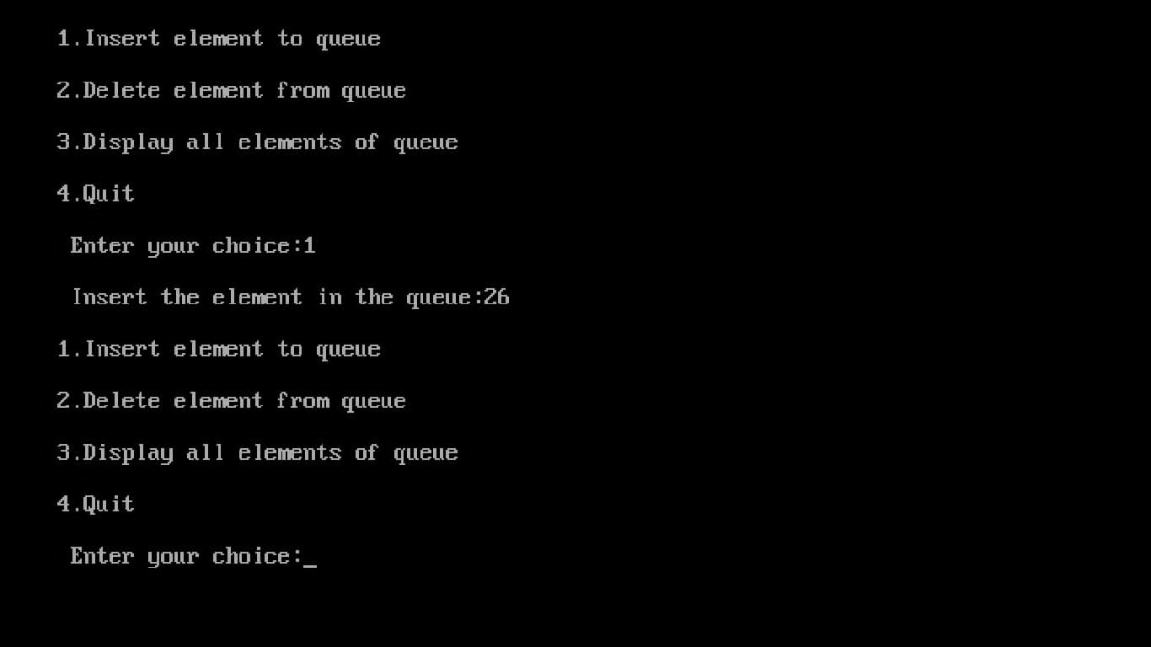

**Conclusion :**

The queue data structure is a linear type of data structure that is used to store the elements. In this data structure elements are stored in the FIFO technique. A queue data structure used an array or linked list during its implementation.